Assignment 5 for Introduction to Life Sciences

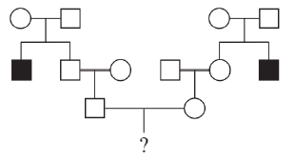
II-1=dd 又I-1与I-2不患病 故I-1=Dd I-2=Dd
II-2不患病 故II-2有1/3概率为DD 2/3概率为Dd
默认II-3是纯合DD 则III-1有2/3概率为DD 1/3概率为Dd
类似分析可得III-2有2/3概率为DD 1/3概率为Dd
故IV-1有1/36概率患病

Feature | Genetic Mutation | Regulation of Gene Express
Fundamental Change | Genotype | Phenotype
Permanence | Permanent | Dynamic
Effect | Little Possibility | Normalization
Most significantly, genetic mutation can be seen as a change to a whole species, for it renews the gene pool, which may bring vigor to the species. The regulation of gene express instead could be seen as a change to a single individual, enable cells to cope with complex and variable environments.
- A static gene needs to go through a set of steps called the central dogma from genotype to phenotype, which, in general, is a “DNA-RNA-protein” chain. By tracing this chain, we can analyze how gene expression is regulated between different cells of the same genotype.
  - Transcriptional regulation
    - Cis-acting element
      - Promoter
      - Enhancer
      - Silencer
    - Trans-acting factor
      - Transcription factor
  - Epigenetic regulation
    - DNA methylation
    - Histone modification
  - Post-transcriptional control
    - 5’ hat
    - 3’ poly A
    - RNA splicing
  - RNA level regulation
    - mRNA stability
    - Regulation of non-coding RNA
      - miRNA
      - siRNA
      - lncRNA
    - Translational inhibition
  - Post-translational regulation
    - Chemical modification
    - Protein folding and assembly
    - Protein degradation

